1. **Source code**

The source code of the “Embedded Virtual Sensor for Lithium-ion Batteries” is named as “CoEst_offline.c”. Along with the C code, there two input files: “current_pisa.txt” and “voltage_pisa.txt”.

The code and input files can be found using the following links:

1. CoEst_offline.c: [Link 1](https://drive.google.com/file/d/1WjzDkaD576nDa3tW5V0Fw5MXdCvJVimB/view?usp=sharing)
2. Current_pisa.txt: [Link 2](https://drive.google.com/open?id=1abQxTtvo5PJzFOayyba7NFyWQbBrK_Yr)
3. voltage_pisa.txt: [Link 3](https://drive.google.com/open?id=1Dm75sCnnMcYKTgL4HXTZ-6EEt2Zk5Ki-)
4. **Input data**

The input of the code is (1) the load current and (2) the terminal voltage of the battery (variables ‘curr’ and ‘volt’ in “CoEst_offline.c”). They are imported from the “current_pisa.txt” and “voltage_pisa.txt” at the beginning when the C code is running.

Note that the sampling time of the input variables is 0.1 second (for both load current and terminal voltage), which is same as the sampling time set for the C program.

1. **Outputs**

The output of the C program is “out_est_SOC.txt”. There are four column in the output file: (1) time stamp, (2) estimated SOC (%), (3) reference SOC (%), and (4) SOC estimation error (%).

To compile the C program in terminal, please type:

gcc [filename] -o [output file name] -lm (Please do not forget to type -lm.)

E.g.: gcc CoEst_offline.c -o CoEst_offline -lm

To run the C program in the terminal, please type:

./[output file name]

E.g.: ./CoEst_offline

1. **Algorithms**

The description of the Co-Estimation algorithm can be found in [This Paper](https://ieeexplore.ieee.org/abstract/document/6517243).

The battery SOC Co-Estimation algorithm performs two estimations in the same computing cycle, as shown in Figure 1. Firstly, the parameters of the battery (*R*0, *R*1, *C*1, *b*1/*QR*) are identified using linear regression approaches, such as autoregressive exogenous average (ARX). Then, the battery SOC observer estimates the SOC of the battery using the latest identified parameters.

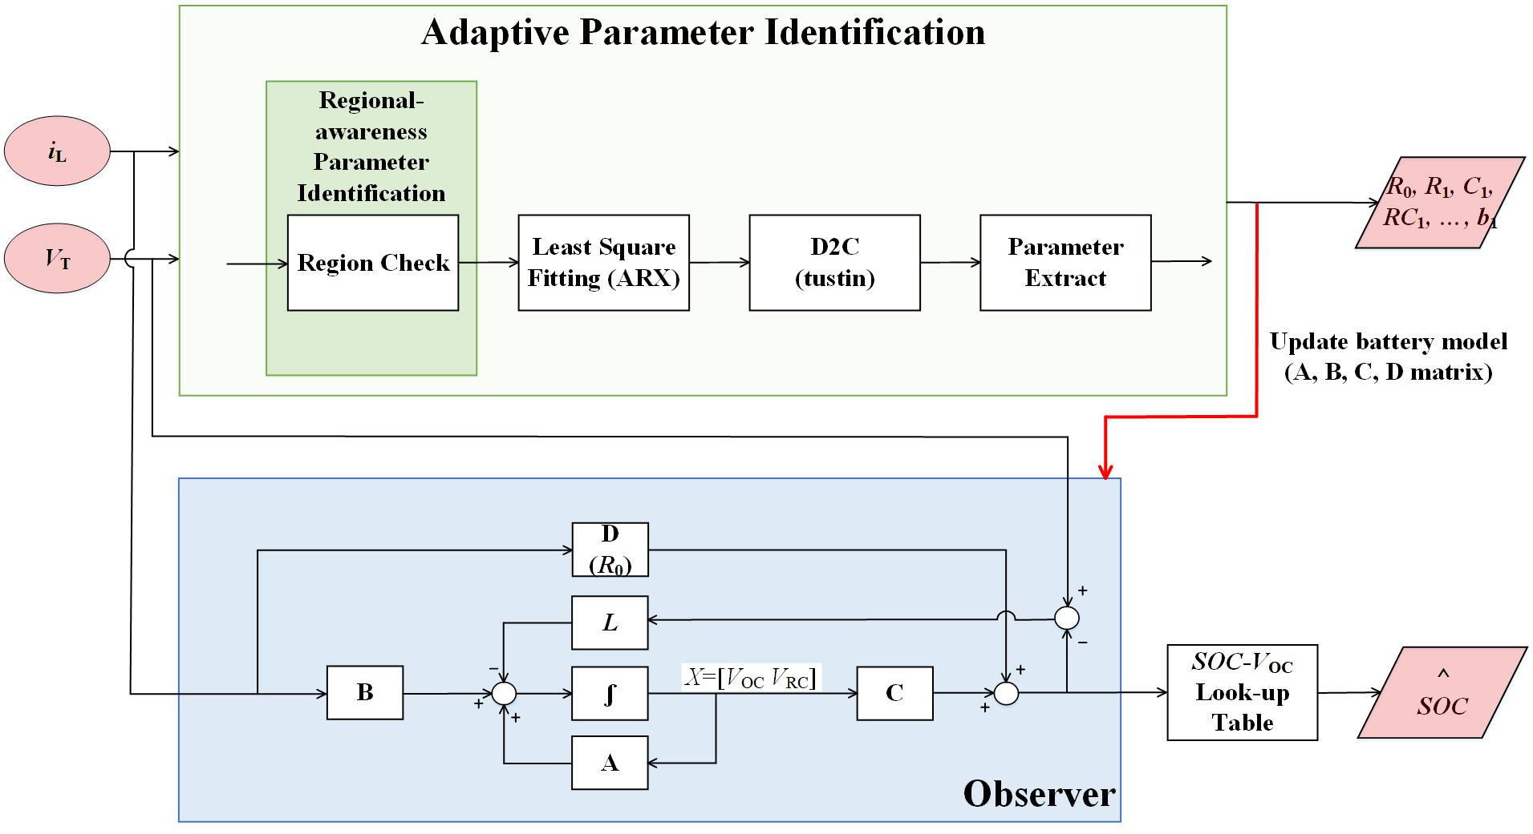

Figure 1. Block diagram of the Co-Estimation algorithm.